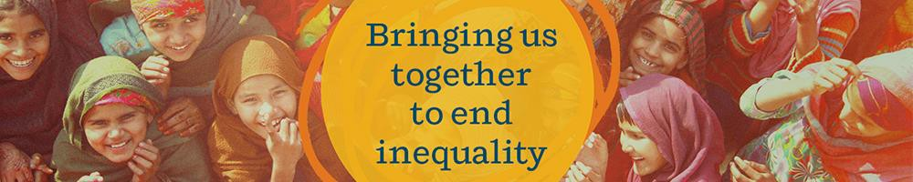

CARE is looking for a Chief of Party (COP) based in Zambia!

ABOUT THE ROLE / WHAT THE ROLE OFFERS

The role of the Chief of Party is to successfully manage SHE SOARS, a multi-country (Zambia, Uganda and Kenya) Adolescent Sexual and Reproductive Health and Rights (ASRHR) project, being implemented by CARE, The Center for Reproductive Rights, and Restless Development, funded by the Government of Canada. This position requires experience working on a Global Affairs Canada (GAC) funded project, excellent program management skills and a deep desire to support and nurture youth-led programming and feminist partnership principles.

The Chief of Party will work closely with CARE Canada’s Global Programs team and lead the work of the Program Management Unit (PMU) made up of Gender, MEAL and Financial Specialists based in Lusaka. The Chief of Party will coordinate with and support the project teams leading implementation in the three countries, as well as work closely with the project’s global partners to ensure high quality programming, innovation, and learning. This position reports to both the Head of Program Management at CARE Canada, as well as the Country Director at the CARE Zambia Office in which this position is based.

The position will provide strategic leadership and ensure that project activities integrate wider CARE and partner learning and best practices as well as feed in and complement CARE’s global advocacy and learning efforts. The role will ensure that project activities are adapted for the unique implementation contexts, while also identifying key approaches for shared learning and scale-up. Key to this role is identifying opportunities for meaningful youth engagement, in partnership with the project’s Youth Advisory Board to ensure adolescent girls, and boys are supported to share their ideas, perspectives and experiences at all steps of the project management cycle.

The successful candidate will work from the Lusaka CARE Office with required travel to Kenya and Uganda. The successful candidate must have the legal authorization to work in Zambia

WHAT YOU OFFER / ABOUT YOU

• Minimum 10 years of experience in global health/SRHR programming; at least 4 of which have been in a management position
• Demonstrated program management experience with projects of similar size (20M+ CAD) and complexity
• Demonstrated capacity in gender equality, in particular understanding of feminist programming and integrating gender into SRHR and Health interventions
• Experience and understanding of successful male engagement strategies, and approaches that foster social and gender norms transformation
• Demonstrated experience in safeguarding and overseeing strong feedback and
accountability mechanisms.
• Demonstrated success with staff supervision and development
• Excellent verbal and written communication skills in English
• Proficiency in standard office software packages and strong organization and calendar management skills
• Excellent interpersonal skills
• Firm belief in and demonstrated commitment to gender equality, diversity and inclusion
• A minimum of 3 - 5 years managing for results using Results Based Management
(RBM) tools
• Excellent written communication skills and the ability to convey complex programming to a range of audiences
• Experience working across cultures to build trust and effective relationship
• Comfort delivering presentations and speaking to a range of audiences
• Experience in applying rights-based and gender transformative approaches to programming
• Expertise in developing and managing budgets
• Expertise in one or more of the following programming areas: gender, public health, adolescent health rights, health system strengthening

WHAT WOULD MAKE YOU EXTRAORDINARY

• Kiswahili, Nyanja or Bemba language skills
• Experience managing a Global Affairs Canada funded project
• Experience with GBV prevention and response
• Safeguarding and/or Child Protection expertise

REQUIREMENTS

• Promote and maintain an organizational culture that advances gender equality, reduces power abuse and inequalities, and fosters trust and safety.
• Create an environment within CARE’s workplaces, programming, and communities where CARE works that is free from sexual harassment, sexual abuse and sexual exploitation and child abuse (SHEA-CA).

• Ensure high standards of prevention and response measures for SHEA-CA are in place consistent with the CARE International (CI) Safeguarding Policy and Safeguarding Code of Conduct.

If you are someone who thrives on challenge, loves to be part of a dynamic team and you are passionate about making a difference, then this opportunity is for you! Don’t think you check all the boxes? Apply anyway – we would love to hear how your experience aligns with this role! Please apply directly at https://tinyurl.com/5fxscje3 by October 4, 2024. Please note resumes will be reviewed on an ongoing basis and the advertisement will be removed once a candidate has been identified. We are only able to consider candidates who currently have the right to work in Zambia.

CARE Canada is committed to employment equity, welcomes diversity in the workplace and encourages applications from all qualified applicants. Recruitment-related accommodation for persons with disabilities is available on request.

As part of CARE’s commitment to preventing sexual harassment, exploitation and abuse, we conduct reference checks on all final stage candidates in line with the Interagency Misconduct Disclosure Scheme. By applying to this role, you are giving us consent to contact your previous employers to seek information in line with this scheme.

